**문자열 연산**

1. **Select *from sample35;**
2. **Select concat(quantity,unit)from sample35;.**

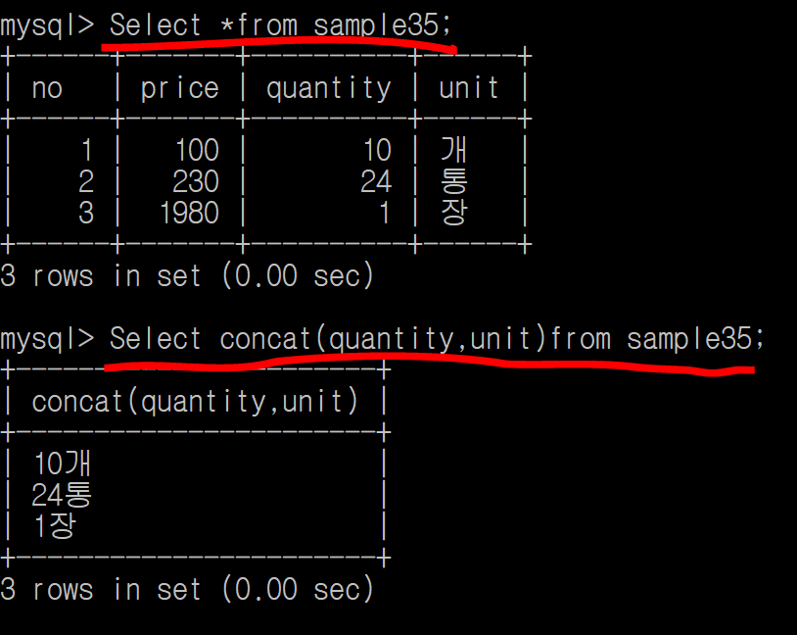

**Quantity + unit 문자열을 합쳤음!**

1. **Select *from sample31;**
2. **Select substring(address,1,2)from sample31;.**
3. **Select substring(address,3,3)from sample31;.**

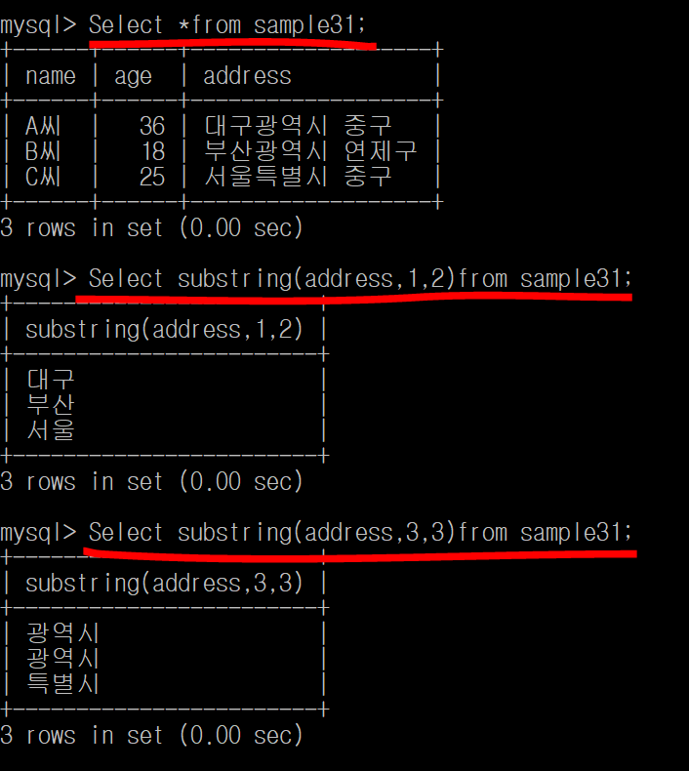

**Address 열에서 1번째부터 2칸만 출력**

**Address 열에서 3번째부터 3칸만 출력**

1. **Select *from sample31;**
2. **Select character_length(address)from sample31;.**

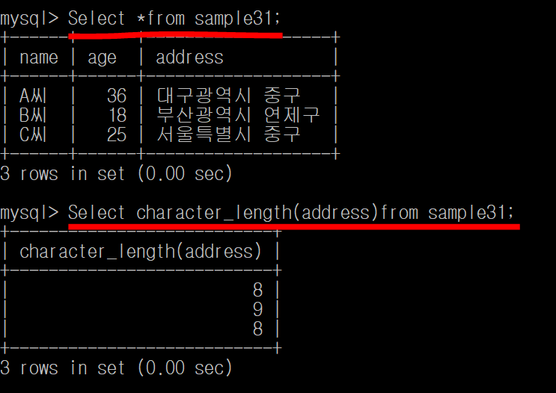

**Address 열 문자열 개수 출력**